Before you begin
Please use the same account for all registrations. This will ensure proper assessment tracking for your skater and avoid any membership fee duplication.
Accepted methods of payment are Visa and Mastercard.
Any credits to your account from previous seasons will be automatically applied at check out.

Click on Registration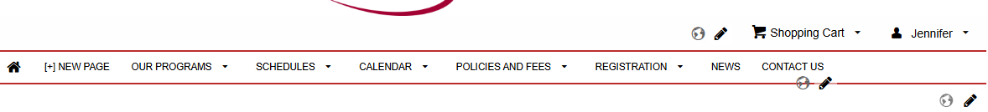

Find your desired program and click Register
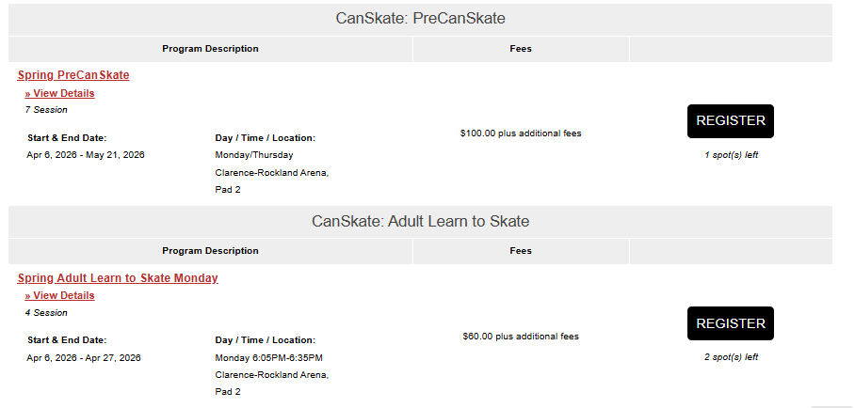

Select the skater you would like to register, click OK, then View Cart
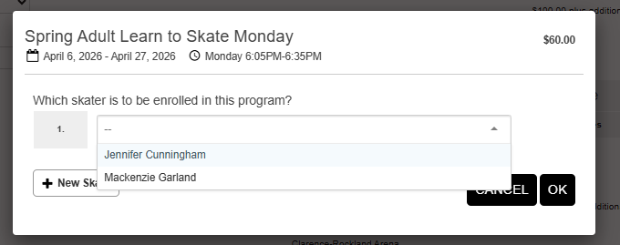

If you have another skater to register, click Add Program. If not, click Billing Information
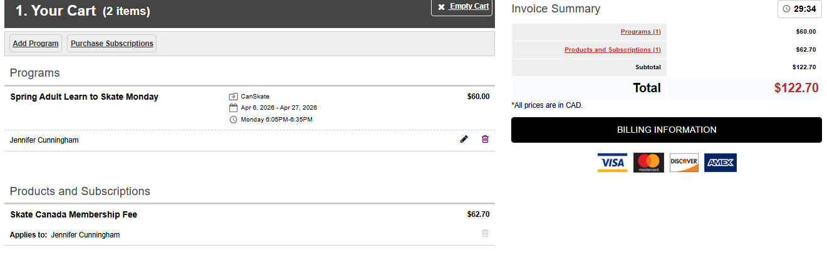
Review and accept any required policies, then click Payment Information
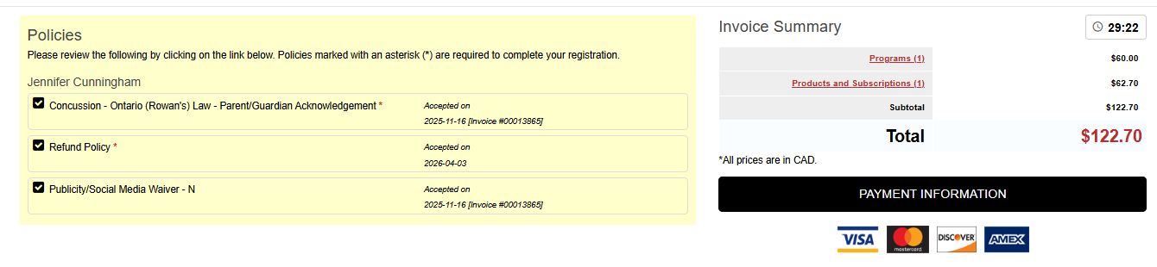
After clicking Payment Information, enter your payment details and click Submit.
Once registration is complete, your session schedule can be viewed on the calendar in your account.

